**Aryaman Mishra**

**19BCE1027**

**Date-6/12/21 LAB FAT**

**Aim:**



**Software used:** LTSpice

**Components required:** Resistors, voltage source, inductors, diode.

**Circuit:**

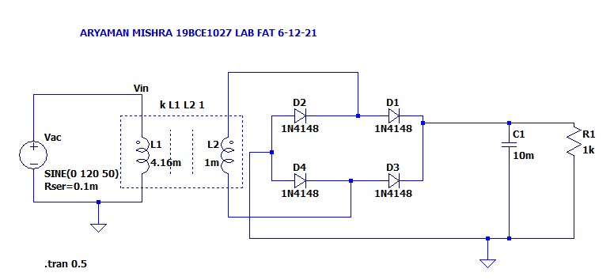

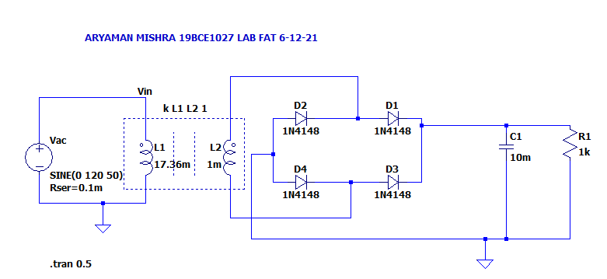

**Output:**

**Taking voltage and number of turns only:**

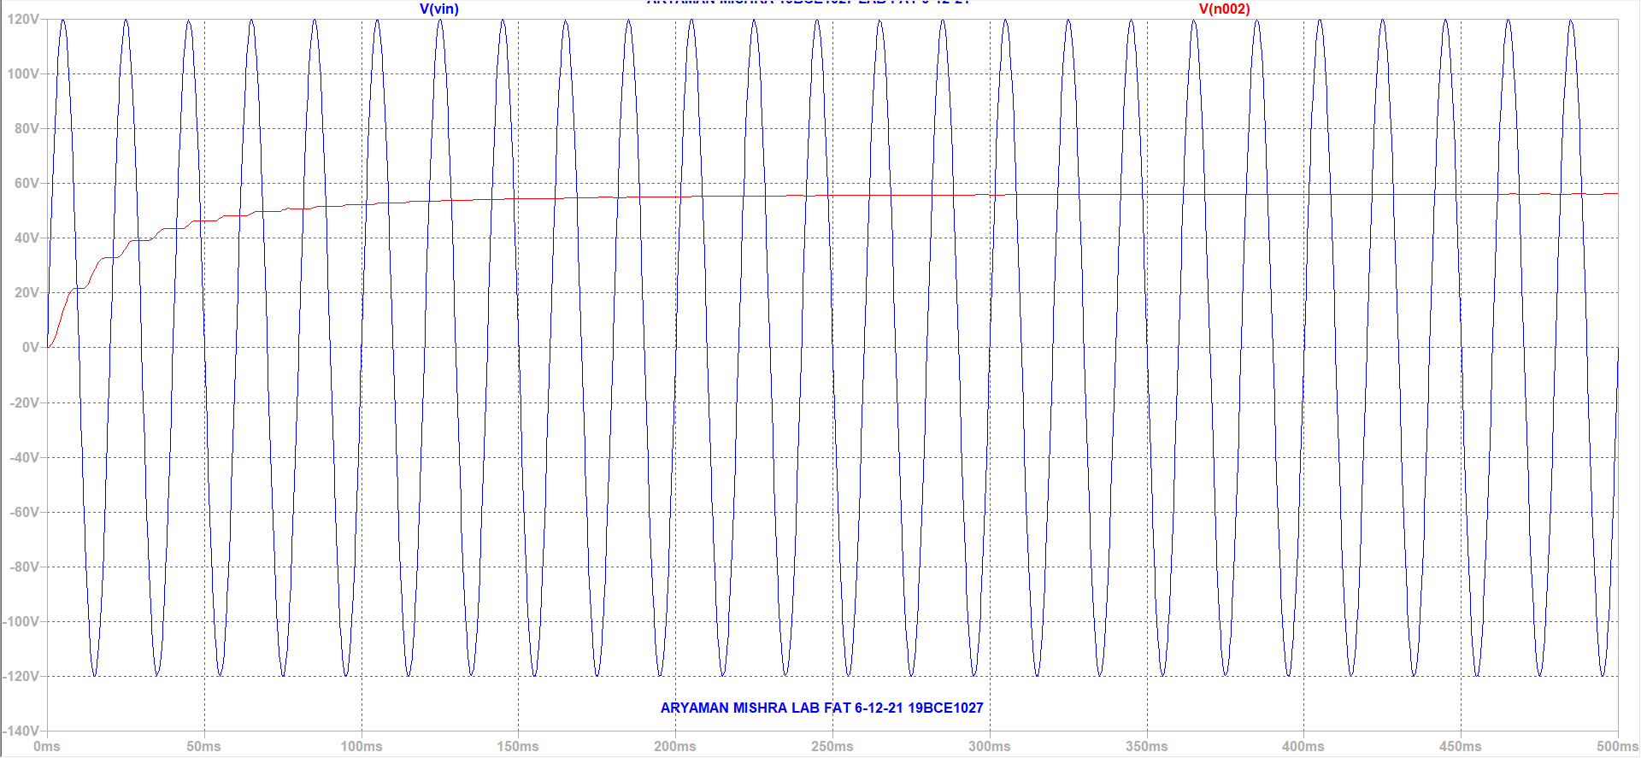

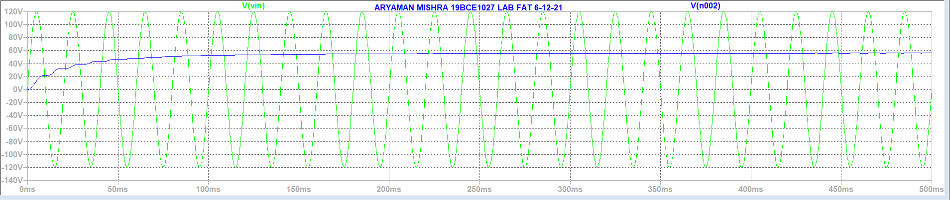

**Taking inductance as factor:**

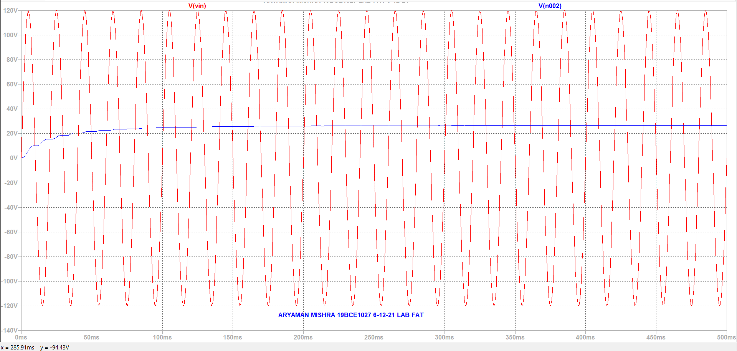

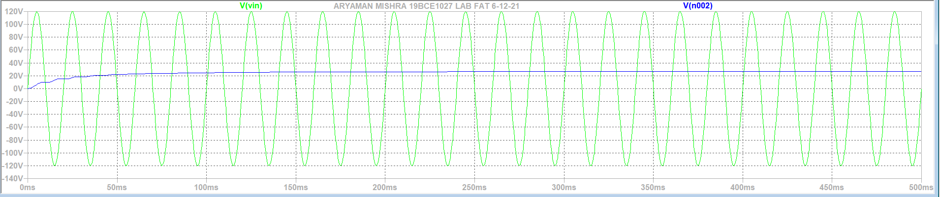

**Taking Voltage and Number of Turns:**

Vp:Input Voltage on Primary Coil

Vs:Input Voltage on Secondary Coil

Ns:Number of Turns on Secondary Coil

Np:Number of Turns on Primary Coil

Turn Ratio Formula:(Vs/Vp)=(Ns/Np)

Turn Ratio=120/28.8=4.16

Therefore:Turn Ratio=4.16:1

**Taking Inductance as factor:**

L1:L2=(v1*v1)/(v2*v2)

L1:L2=(120*120)/(28.8*28.8)=17.36:1

**Conclusion: On taking L1:L2 as 17.36:1,the threshold voltage peaks at 28.8V.Thus experiment is successfully completed.**